34.48: a) Angular magnification 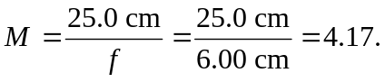
b) 